How to Pull a Current Price List

-Login to your account with Administrator credentials
-Click on “View Account”:
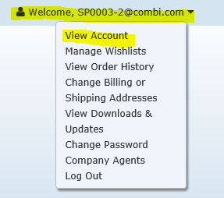
-Click “Item Listing”
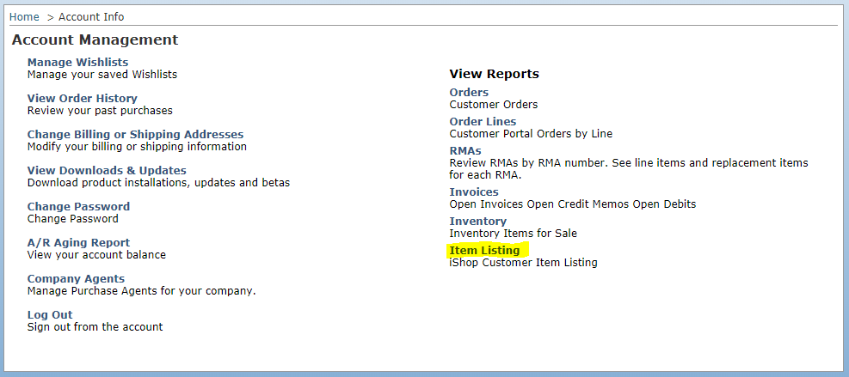
This is a complete list of products available for purchase, please note the prices are list price.
-Scroll to the bottom of the page and update the page size to the total number of items so that all items are shown on one page.
Before:
After:

-Select All/Highlight and Copy
-Open a new Excel sheet and Paste the report

